1 | B.M.A.RAJA KUMARA | Director General | 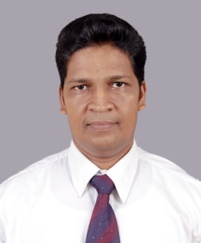 | HO
2 | H.K.SUDARSHANA | Director(Operation & planning) | 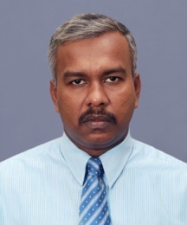 | HO
3 | A.K.P.K.JAYASIRI | Director (Admin, Development & Finance) |  | HO
4 | H.W.ARIYASENA | Assistant/Deputy Director | 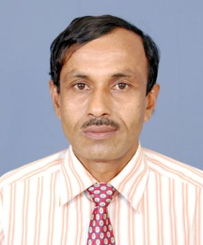 | HT
5 | K.D.S.RUPASIGHE | Assistant/Deputy Director | 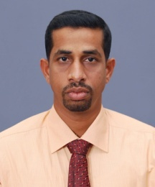 | GL
6 | M.D.JAYASINGHA | Assistant/Deputy Director |  | MT
7 | N.S.GURUSINGHE | Assistant/Deputy Director |  | HO
8 | N.K.M.M.PRASANGA | Assistant/Deputy Director(Administration) | 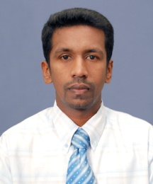 | HO
9 | G.H.G.N.HEMANTHA | Assistant/Deputy Director(Development, Training & Research) | 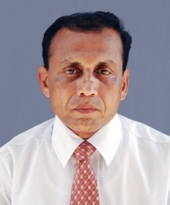 | HO
10 | M.V.R.K.MANEL | Accountant | 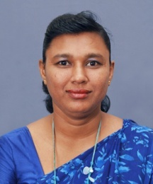 | HO
11 | G. R.L.BERNARD | Planning Officer | 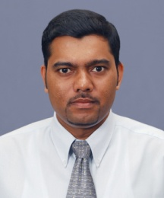 | HO
12 | K.G.WIMALAWATHIE | Transport Officer | 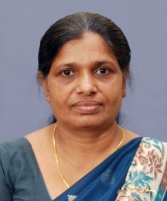 | HO
13 | A.H.PATHMALAL | Transport Officer | 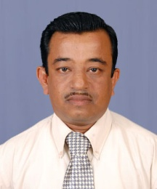 | HT
14 | M.PUSHPA KUMARA | Transport Officer | 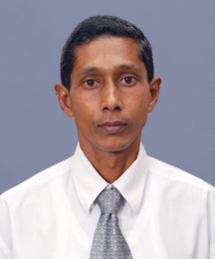 | HO
15 | N.G.SAMAN | Transport Officer | 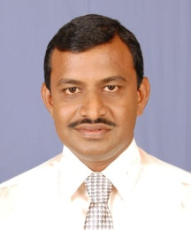 | MT
16 | U.J.PREBATH | Transport Officer |  | GL
17 | S.S.A. SARACHCHANDRA | Administrative Officer | 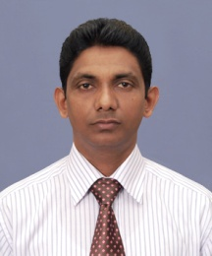 | HO
18 | I.U.KARIYAWASAM | Internal Audit Officer | 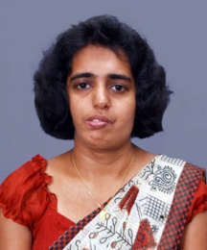 | HO
19 | W.H.M.N.RANBANDA | Senior Inspector | 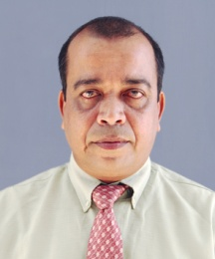 | GL
20 | M.A.G.GAMINI | Senior Inspector |  | GL
21 | G.A.BADDEVITHANA | Senior Inspector | 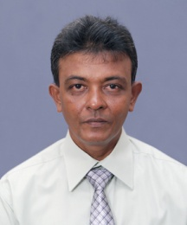 | GL
22 | B.G.RANJITH | Senior Inspector | 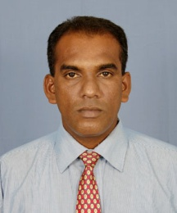 | MT
23 | H.A.C.CHINTHANA | Senior Inspector |  | GL
24 | S.L.GODEVITHANA | Senior Inspector | 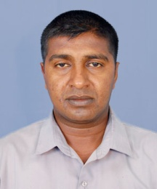 | MT
25 | A.P. NALAKA | Senior Inspector | 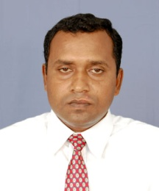 | MT
26 | P.V.N. NILANTHA | Senior Inspector |  | GL
27 | K.D. PRASAD | Senior Inspector | 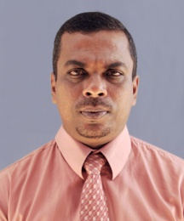 | GL
28 | L.H.C.P.KUMARA | Senior Inspector | 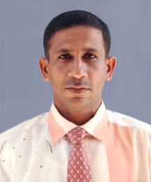 | GL
29 | T.A. PRIYANTHA DE SILVA | Senior Inspector | 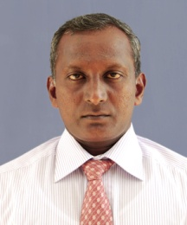 | GL
30 | H.L.C.D.WEERATHUNGA | Senior Inspector | 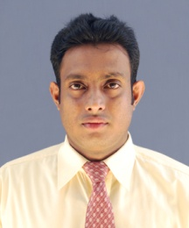 | HO
31 | D.GUNASEKARA | Senior Inspector
32 | D.A.V.K.DINARATHNA | Senior Inspector | 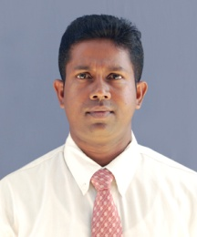 | HO
33 | K.W.A.N.PRIYADARSHNA | Senior Inspector
34 | G.G.WICKRAMASIRI | Time Table Assistant | 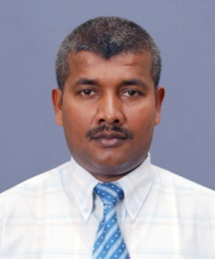 | HO
35 | N.C.LIYANAGE | Time Table Assistant | 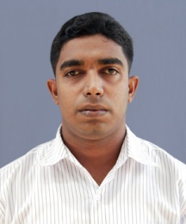 | HO
36 | C.D.GAMAGE | Time Table Assistant | 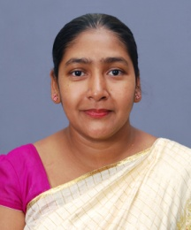 | HO
37 | G.H.G.D.P.KUMARA | Time Table Assistant | 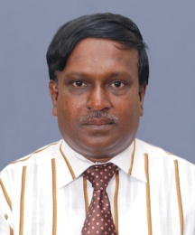 | HO
38 | L.H. SAGARA DE SILVA | Court Assistant
39 | W. J. E. MENDIS | Management Assistant
40 | K.H.G.U.RANJAN | Management Assistant | 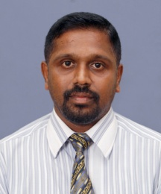 | HO
41 | L.G.RUWAN | Management Assistant | 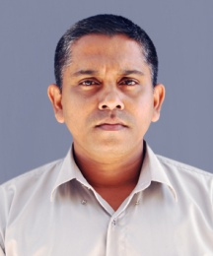 | GL
42 | I.WICKRAMASEKARA | Management Assistant |  | MT
43 | M.K.D. SAMANTHA | Management Assistant | 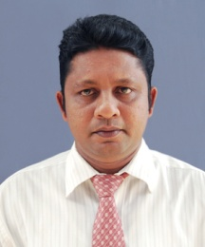 | GL
44 | K.K.G. SUDATH PRIYANTHA | Management Assistant |  | MT
45 | K.G.R.M.PRIYADARSHANI | Management Assistant | 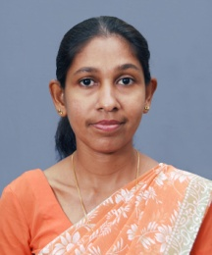 | HO
46 | I.D.A.JAYASINGHE | Management Assistant | 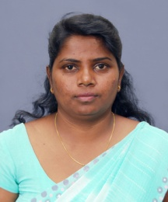 | HO
47 | P.H.K.JANAPRIYA | Management Assistant | 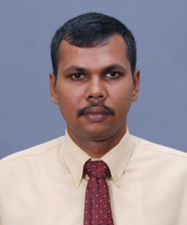 | HO
48 | G.S.G.A.GANEGODA | Management Assistant | 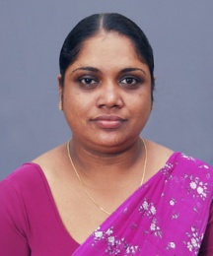 | HO
49 | S.R.ARIYATHILAKE | Management Assistant | 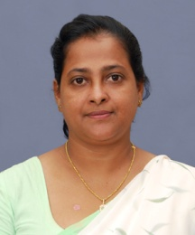 | HO
50 | K.G. MADURA ASANTHA | Management Assistant | 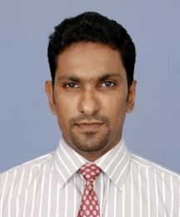 | M
51 | A.V.P.U.KUMARA | Management Assistant | 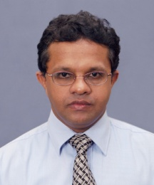 | HO
52 | M.A.BANDUKUMARA | Management Assistant | 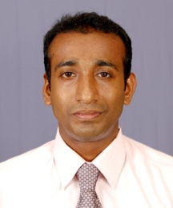 | HT
53 | K.H.T.K.KUMARA | Management Assistant | 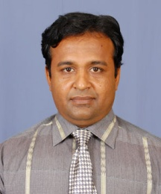 | HT
54 | L.A.VITHANA | Management Assistant |  | MT
55 | L.P.C.R.KUMARA | Management Assistant
56 | H.DARMASIRI | Management Assistant | 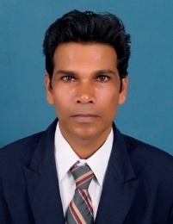 | HO
57 | G.A.P.INDRALAL | Management Assistant |  | GL
58 | J.P.A.S.JAYANETHTHI | Management Assistant | 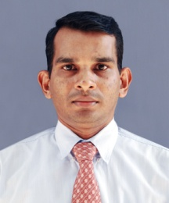 | GL
59 | M.M.KARANAYAKA | Management Assistant | 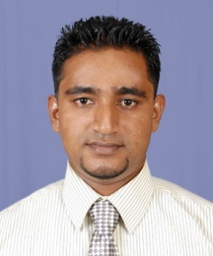 | HT
60 | R. P. DE S.WAIDYASEKARA | Management Assistant | 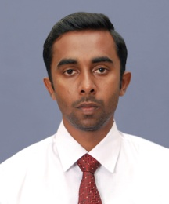 | HO
61 | A.T.K DE SILWA | Management Assistant | 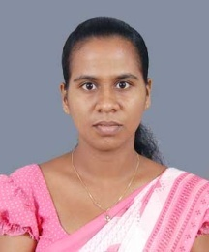 | HO
62 | D.P.WIJEHEWA | Management Assistant
63 | H.L.I.MADUSHANI | Management Assistant |  | MT
64 | W.A.K.UDAYANGANI | Management Assistant | 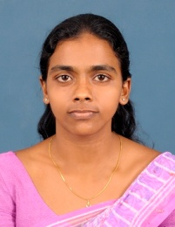 | HO
65 | P.A.C.SAUMYA | Management Assistant | 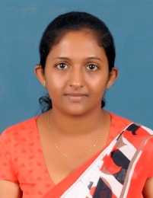 | HO
66 | W.P.THUSHANI | Management Assistant | 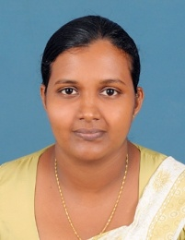 | HO
67 | L.GURUSINGHE | Management Assistant | 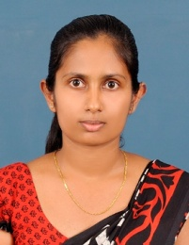 | HO
68 | N.D.RANAWEERA | Management Assistant | 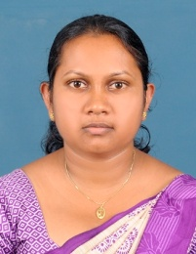 | HO
69 | W.D.PRASADINI | Management Assistant | 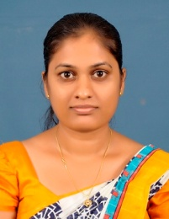 | HO
70 | W.R.N.JAYAWARDANA | Management Assistant | 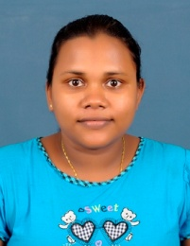 | HO
71 | A.I.MADUSHANKI | Management Assistant |  | HO
72 | T.D.WICKRAMASEKARA | Management Assistant |  | HO
73 | S.SUNIL | Management Assistant
74 | D.S.Y.R.KUMARI | Management Assistant |  | -
75 | H.R.P.I.GUNASEKARA | Point Controller/Flying Squad
76 | V.U.S.EDMOND | Point Controller/Flying Squad | 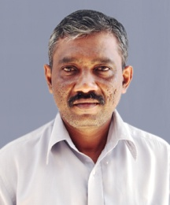 | GL
77 | M.K.A.ASOKA | Point Controller/Flying Squad | 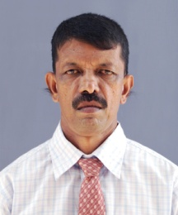 | GL
78 | C.KODIPPILI | Point Controller/Flying Squad
79 | G.L.A.ARIYADASA | Point Controller/Flying Squad
80 | K.H.S.GUNARATHNA | Point Controller/Flying Squad
81 | R.A.ANANDA | Point Controller/Flying Squad
82 | U.L.R.AMARASINGHA | Point Controller/Flying Squad
83 | S.S.KURUPPUARACHCHI | Point Controller/Flying Squad
84 | H.A.WEERATHILAKA | Point Controller/Flying Squad
85 | S.P.A.KUMARA | Point Controller/Flying Squad
86 | E.P. GAMINI | Point Controller/Flying Squad
87 | R.D. LOKUMARAMBAGE | Point Controller/Flying Squad
88 | R.P.SAMAN | Point Controller/Flying Squad
89 | W.P.NIHAL | Point Controller/Flying Squad
90 | A.K.JAYASINGHE | Point Controller/Flying Squad
91 | L.P.U.RUWAN | Point Controller/Flying Squad | 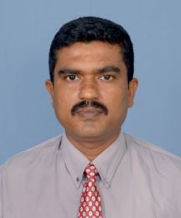 | MT
92 | K.J.M.S.PRASANNA | Point Controller/Flying Squad
93 | P.H.N.A.KUMARA | Point Controller/Flying Squad | 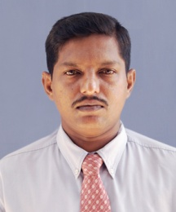 | GL
94 | S. L. MEEGAMA | Point Controller/Flying Squad | 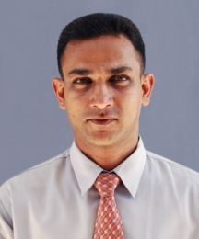 | GL
95 | W.M.S.CHANDANA | Point Controller/Flying Squad
96 | N.S.W.ASANGA DE SILVA | Point Controller/Flying Squad | 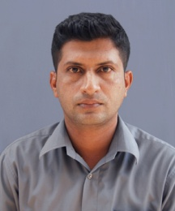 | GL
97 | H.P.PIYASOMA | Point Controller/Flying Squad | 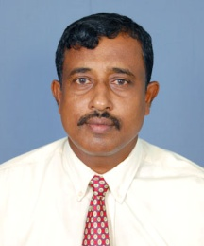 | MT
98 | D.WICKRAMASINGHE | Point Controller/Flying Squad
99 | N.H.MAITHREEPALA | Point Controller/Flying Squad
100 | W.RASIKA | Point Controller/Flying Squad
101 | J.P. JAYARATHNA | Point Controller/Flying Squad
102 | P.H.D.MOHAN | Point Controller/Flying Squad | 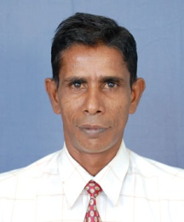 | MT
103 | S.S. HETTIARACHCHI | Point Controller/Flying Squad
104 | S.H.GAMINI DE SILVA | Point Controller/Flying Squad
105 | K.R.P.J.CHAMINDA | Point Controller/Flying Squad
106 | W.H.S.RANAWEERA | Point Controller/Flying Squad
107 | K. M.SOMARATHNA | Point Controller/Flying Squad
108 | A. L. K.PUSHPAKUMARA | Point Controller/Flying Squad
109 | K.W.A.SHANTHA | Point Controller/Flying Squad
110 | W.K.DARMAPALA | Point Controller/Flying Squad
111 | K. L.ARIYARATHNA | Point Controller/Flying Squad
112 | W.A.S.NISHANTHA | Point Controller/Flying Squad
113 | K.W.PRIYANTHA | Point Controller/Flying Squad
114 | A.G.S.S.PERERA | Point Controller/Flying Squad
115 | D.G.M.UDAYANGA | Point Controller/Flying Squad
116 | H.G.A.P.GUNAPALA | Point Controller/Flying Squad
117 | A.D.K.THUSHARA | Point Controller/Flying Squad
118 | P.H.N.E.DE SILVA | Point Controller/Flying Squad
119 | H.H.I.P.DE SILVA | Point Controller/Flying Squad
120 | W.M.DARMADASA | Point Controller/Flying Squad
121 | A.R.GAMAGE | Point Controller/Flying Squad
122 | H.G.U.KUMARA | Point Controller/Flying Squad
123 | C.J.KALUPAHANA | Point Controller/Flying Squad |  | GL
124 | P.A.A.WITHANA | Point Controller/Flying Squad
125 | H.G.D.TUSHARA | Point Controller/Flying Squad
126 | M.W.G.PRIYANTHA | Point Controller/Flying Squad
127 | M. M.D.ASHAN | Point Controller/Flying Squad
128 | E.G.S.KUMARA | Point Controller/Flying Squad
129 | W.H.C.JEEVANLAL | Point Controller/Flying Squad
130 | W.PRIYANTHA | Point Controller/Flying Squad
131 | D.T.C.ABEGUNASEKARA | Point Controller/Flying Squad
132 | E.M.K.L.MANJULA | Point Controller/Flying Squad
133 | S.D.P.W.KUMARA | Point Controller/Flying Squad
134 | K.P.P.R.KUMARA | Point Controller/Flying Squad
135 | G.W.K. WIMALAGUNASEKARA | Point Controller/Flying Squad
136 | P.K.THENUWARA | Point Controller/Flying Squad
137 | P.K.NANDASENA | Point Controller/Flying Squad
138 | S.W.T.WAJIRAMAL | Point Controller/Flying Squad |  | HO
139 | D.M.R.P.SAMPATH | Point Controller/Flying Squad
140 | S.K.R.NADEESHAN | Point Controller/Flying Squad | 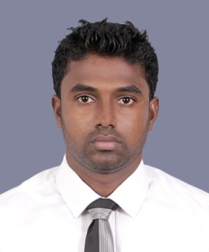 | HO
141 | T.L.R.SHASHIN | Point Controller/Flying Squad | 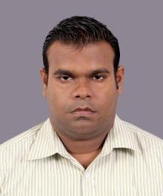 | HO
142 | P.P.JAYAWARDENA | Point Controller/Flying Squad
143 | H.G.S.DAMITH | Point Controller/Flying Squad
144 | H.K.D.ERANDIKA | Point Controller/Flying Squad
145 | K.L.A.J.P.WEERASINGHE | Point Controller/Flying Squad
146 | B.RAVEENDRA | Point Controller/Flying Squad | 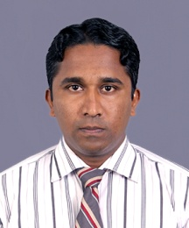 | HO
147 | D.H.VITHANA | Point Controller/Flying Squad
148 | R.Y.D.W.J.KWEERAMAN | Point Controller/Flying Squad
149 | S.W.G.S.RANJAN | Point Controller/Flying Squad
150 | K.G.D.D.SENARATHNA | Point Controller/Flying Squad
151 | G.T.JAYASINGHE | Point Controller/Flying Squad
152 | B.K.RUWAN KUMARA | Point Controller/Flying Squad
153 | L.A.MALLAWAARACHCHI | Point Controller/Flying Squad
154 | W.K.A.T.LAKMAL | Point Controller/Flying Squad
155 | G.P.T.SAMPATH | Point Controller/Flying Squad
156 | C.G.ARACHCHIGE | Point Controller/Flying Squad
157 | M.A.M.GUNATHILAKA | Point Controller/Flying Squad
158 | W.MAHESH | Point Controller/Flying Squad
159 | K.T.D.MADHUSANKA | Point Controller/Flying Squad
160 | P.H.I.MADUSANKA | Point Controller/Flying Squad
161 | H.N.K.C.D.GUNASIRI | Point Controller/Flying Squad
162 | D.M. GAMAGE | Point Controller/Flying Squad
163 | H.T.T.R.DE SILVA | Point Controller/Flying Squad
164 | P.H.T.K.UBAYAWARDHANA | Point Controller/Flying Squad
165 | K.H.R.LAKSHAN | Point Controller/Flying Squad
166 | E.NISHAN VITHARANA | Point Controller/Flying Squad
167 | T.H.D.G. DE SILVA | Point Controller/Flying Squad
168 | K.K.M.K.INDHRAJITH | Point Controller/Flying Squad
169 | P.H.D.R.DILUSHA | Point Controller/Flying Squad
170 | D.G.M.INDRASIRI | Point Controller/Flying Squad
171 | A.H.W.D.KUMARA | Point Controller/Flying Squad
172 | M.G.BANDULA | Point Controller/Flying Squad
173 | D.G.SUNIL | Driver | 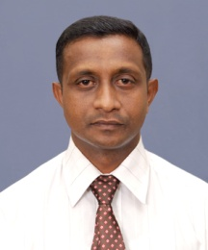 | HO
174 | W.T.R.KUMARA | Driver | 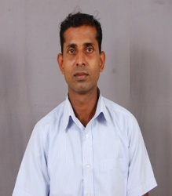 | HO
175 | D.G.S.SAMEERA | Driver | 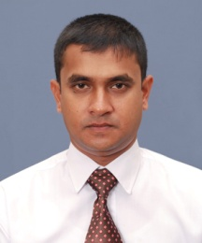 | HO
176 | B.CHAMINDA | Driver
177 | A.G.PRIYANTHA | Office Aide | 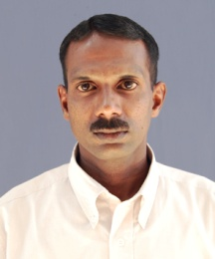 | GL
178 | M.P.WASANTHA | Office Aide
179 | D.W.D.S.KUMARA | Office Aide | 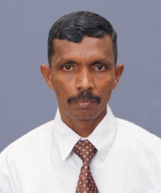 | HO
180 | D.D.M. WICRAMASINGHE | Office Aide
181 | I.WIJESEKARA | Office Aide
1
2
3
4
5
6
7
8
9
10
11
12
13
14
15
16
17
18
19

